Business Requirements Document (BRD)

Marriage Registration Module
Field | Value
Document ID | BRD-K3-MRG-HMA-001
Version | 0.1
Status | Draft / In review
Module | Marriage Registration
Legal basis (primary) | The Hindu Marriage Act, 1955; The Special Marriage Act, 1954
State rules (primary) | Registration of Hindu Marriage (Karnataka) Rules, 1966; Special Marriage (Karnataka) Rules, 1961
Related inputs | Acts_Rules/Marriage/Hindu Marriage Act, 1955.pdf; Acts_Rules/Marriage/The Special Marriage Act, 1954.pdf; Acts_Rules/Marriage/REGISTRATIONOFHINDUMARRIAGE_KARNATAKARULES_1966.docx; Acts_Rules/Marriage/SpecialMarriage(Karnataka)Rules1961.pdf; Acts_Rules/Marriage/SpecialMarriageFees.docx; Acts_Rules/Marriage/hindu marriage forms.pdf; Acts_Rules/Marriage/RD48MNMU2023-Notification-marriage.pdf
Author (BA) | Nandha Kumar
Product Owner | Prashanth
Domain expert / SRO reviewer | Prabhakar Naik,
Target audience | Kaveri IT Cell, Department of Stamps and Registration, Government of Karnataka
Last updated | 2026-08-24

Document control
Version | Date | Author | Summary of change | Approver
0.1 | [Date] | Nandha Kumar | Initial template / discovery draft | Prashanth

Related documents:
ID | Title | Link
BRD-K3-MRG-HMA-001 | This document
PROC-K3-MRG-HMA-TOBE-001 | Process flows | Process Diagrams/hindu marriage Online.png, Process Diagrams/hindu marriage Offline.png, Process Diagrams/Special Marriage (Intended Marriage) Notice generation-Online.png, Process Diagrams/Special Marriage (Intended Marriage) Notice generation- offline.png, Process Diagrams/Special Marriage (Intended Marriage) Marriage Registration.png, Process Diagrams/Special Marriage Other Forms Notice generation-Online.png, Process Diagrams/Special Marriage Other Forms Notice generation- offline.png, Process Diagrams/Special Marriage Other Forms Marriage Registration.png
RTM-K3-MRG-HMA-001 | Requirements traceability matrix | link

Contents
1. Executive summary
2. Scope
2.1 In scope (Hindu Marriage & Special Marriage — Phase [1])
2.2 Out of scope (unless PO promotes)
2.3 Assumptions
2.4 Constraints
3. Legal and regulatory reference
3.1 Primary legislation — Hindu Marriage Act, 1955
3.2 Karnataka Rules, 1966
3.3 Statutory forms mapping
3.4 Primary legislation — Special Marriage Act, 1954
3.5 Special Marriage (Karnataka) Rules, 1961
3.6 Special Marriage statutory forms mapping
4. Stakeholders and actors
5. Definitions and glossary
6. Current state (As-Is)
6.1 As-Is pain points
7. Future state (To-Be)
7.1 Channel model
7.2 Common intake steps (both channels)
7.3 To-Be process — Hindu Marriage Online
7.4 To-Be process — Hindu Marriage Offline
7.5 To-Be process — Special Marriage (Intended Marriage) Notice Generation Online
7.6 To-Be process — Special Marriage (Intended Marriage) Notice Generation Offline
7.7 To-Be process — Special Marriage (Intended Marriage) Marriage Registration
7.8 To-Be process — Special Marriage Other Forms Notice Generation Online
7.9 To-Be process — Special Marriage Other Forms Notice Generation Offline
7.10 To-Be process — Special Marriage Other Forms Marriage Registration
7.11 Application status model (channel-aware)
8. Functional requirements
8.1 Eligibility and module entry (FR-HMA-001–004)
8.2 Jurisdiction and office routing (FR-HMA-005–006)
8.3 Data capture — marriage details (FR-HMA-007–009)
8.4 Data capture — bridegroom (FR-HMA-010)
8.5 Data capture — bride (FR-HMA-011)
8.6 Data capture — witnesses (FR-HMA-012–014)
8.7 Form I — memorandum generation and completeness (FR-HMA-015–017)
8.7A Form IA — application and declarations (FR-HMA-083–085)
8.8 Supporting documents and memorandum (FR-HMA-018–019)
8.9 Fees and payments (FR-HMA-020–025)
8.10 SRO scrutiny and registration (FR-HMA-026–030)
8.11 Post-registration services (FR-HMA-031–035)
8.12 Notifications (FR-HMA-036–038)
8.13 Reports and MIS (FR-HMA-039–045)
8.14 Channel selection and prerequisite acknowledgement (FR-HMA-046–050)
8.15 Online channel — office, Form I & Form IA, eSign (FR-HMA-051–058, 086–087)
8.16 Offline channel — printout, DEO upload (FR-HMA-059–069)
8.17 SR verification (FR-HMA-070–077)
8.18 Digital signature and certificate issuance (FR-HMA-078–082)
9. Business rules (BR-HMA-001–020)
10. User interface (high-level)
11. Integrations
12. Data requirements
12.1 Core entities (logical)
12.2 Retention
12.3 Migration (high level)
13. Requirements traceability matrix (RTM)
14. Acceptance and sign-off
Appendix A — References

Executive summary
This document presents a comprehensive assessment of the existing Hindu Marriage Registration process and Special Marriage (Intended Marriage / Other Forms) notice and registration processes, covering both online and offline service channels. It identifies key operational, procedural, and user experience challenges currently impacting applicants and Sub-Registrar offices.
Based on the analysis of the current state, the document proposes an enhanced future-state workflow aimed at improving accessibility, efficiency, transparency, and service delivery. In addition, it defines the functional , outlines the data requirements required for effective implementation and management, and provides a reference to detailed traceability matrix to ensure alignment between business objectives, requirements, and solution deliverables.
The proposed approach is intended to streamline marriage registration services, reduce manual effort, enhance compliance, and establish a scalable foundation for future digital transformation initiatives.

2. Scope

2.1 In scope (Hindu Marriage & Special Marriage — Phase [1])
- Registration of already solemnized Hindu marriages under Section 8, HMA 1955.
- Statutory artefacts: Form I (Memorandum), Form IA (Application), Form II-A (Certificate)
- Parties: bride, bridegroom, three witnesses (memorandum signed by three witnesses per Rule 4(3)).
- Citizen portal + SRO desk workflows: apply, pay fee, scrutiny, approve/reject, register, generate certificate.
- Hindu Marriage processing channels per approved process diagrams (7.3–7.4): Hindu Marriage Online and Hindu Marriage Offline.
- Integrations: [payment, Aadhaar/eKYC, DigiLocker, SMS, e-Mail, Kutumba portal, Civil Registration System, Labor Department].
- Bilingual UI: English + Kannada (labels, certificate text where mandated).
- Audit trail, role-based access, MIS/reporting for department.
- References/Endorsements to flag the marriage as NULL and VOID
- Special Marriage — Intended Marriage (Chapter II, SMA 1954): notice of intended marriage (Second Schedule) Online & Offline, 30-day publication / objection period, solemnization and certificate (Fourth Schedule) within statutory validity (diagram gate ≥30 and ≤90 days; aligns to Sec. 7 & Sec. 14).
- Special Marriage — Other Forms (Chapter III, SMA 1954 Sec. 15–16): notice/publication for registration of marriages celebrated in other forms, objection handling, and entry of certificate in Marriage Certificate Book (Fifth Schedule).
- Special Marriage process diagrams (7.5–7.10): Notice Generation Online/Offline and Marriage Registration for both Intended Marriage and Other Forms.
- Special Marriage fees as per Special Marriage (Karnataka) Rules, 1961 / SpecialMarriageFees.docx.

2.2 Out of scope (unless PO promotes)
- Parsee / Sikh marriage Acts.

2.3 Assumptions
ID | Assumption | Owner to validate
A-01 | Sub-Registrars under Indian Registration Act, 1908 act as Registrars of Hindu Marriages for their jurisdiction (Karnataka notification) | Domain Expert
A-02 | Joint photograph on memorandum is required as per Form I layout | Domain Expert
A-03 | Fee schedule follows Karnataka Rules Schedule | Domain Expert
A-04 | Sub-Registrars act as Marriage Officers under SMA 1954 / Special Marriage (Karnataka) Rules, 1961 for Special Marriage services in Kaveri 3.0 | Domain Expert
A-05 | To flag the marriage as NULL and VOID, the feature for entering endorsement shall be added in the system | Domain Expert

2.4 Constraints
- Guidelines for Indian Government Websites and Apps (GIGW) / MeitY guidelines, accessibility (Web Content Accessibility Guidelines.(WCAG)), Karnataka e-Gov hosting/security norms.
- Aadhaar / eKYC usage only as approved by department and UIDAI compliance.

3. Legal and regulatory reference
Primary legislation — Hindu Marriage Act, 1955 (selected sections for registration)
Primary legislation — Special Marriage Act, 1954 (selected sections)
Special Marriage (Karnataka) Rules, 1961
Karnataka Rules, 1966 (operational rules)

3.1 Statutory forms mapping (Hindu Marriage)
Form | Rule ref | Purpose | Generated by
Form I | Rule 4 | Memorandum of marriage (duplicate) | System from captured data + joint photo
Form IA | Rule 4(2) | Application for filing of marriage memorandum | System from captured data + declarations
Form II-A | Rule 4(5) | Certificate of registration | System on approval

3.2 Special Marriage statutory forms mapping
Schedules under the Special Marriage Act, 1954 (as applicable in Kaveri 3.0):
Form / Schedule | Act ref |  | Purpose |  | Generated by
Notice of Intended Marriage (Second Schedule) | Sec. 5 / Sec. 6 |  | Statutory notice for Intended Marriage |  | System + SR generation; portal / notice-board publication
Declarations (Third Schedule) | Sec. 11 |  | Declarations by parties and witnesses before solemnization |  | System / office capture
Certificate of Marriage (Fourth Schedule) | Sec. 13 |  | Certificate after solemnization under Chapter II |  | System on SR DSC
Certificate of Marriage (Fifth Schedule) | Sec. 16 |  | Certificate for marriages registered under Chapter III (Other Forms) |  | System on SR DSC
Section |  | Topic |  | System implication
Sec. 4 |  | Conditions relating to solemnization |  | Eligibility / prerequisite checks before notice
Sec. 5 |  | Notice of intended marriage (Second Schedule) |  | Generate & capture notice; jurisdiction: ≥30 days residence of at least one party
Sec. 6 |  | Marriage Notice Book and publication |  | Enter notice; publish on portal and/or notice board; transmit if party resides elsewhere
Sec. 7 |  | Objection to marriage (30 days) |  | 30-day countdown from publication; accept/record objections
Sec. 8–9 |  | Procedure / enquiry on objection |  | SR enquiry, summon parties; uphold or reject objection
Sec. 11 |  | Declaration by parties and witnesses |  | Declarations before solemnization; three witnesses
Sec. 12–13 |  | Solemnization and certificate of marriage |  | Office solemnization; Fourth Schedule certificate
Sec. 14 |  | New notice if not solemnized within three months |  | Block registration outside validity; require fresh notice
Sec. 15 |  | Registration of marriages celebrated in other forms |  | Other Forms eligibility (ceremony performed; ages; residence ≥30 days; etc.)
Sec. 16 |  | Procedure for registration (Other Forms) |  | Public notice, 30-day objections, Fifth Schedule certificate + 3 witnesses

4. Stakeholders and actors
Actor | Description | Primary goals | Channel involvement
Bride / Bridegroom (citizens/applicant) | Parties to marriage | Sign declarations, provide documents | Online: eSign; Offline: physical signature on printed Form I / IA / II-A
Witness (×3) | Present at solemnization | Identity, address, signature on memorandum | Online: eSign / e-KYC [TBD]; Offline: physical signature
Marriage Registrar / Sub-Registrar (SR) | Statutory registrar | Verification, register, digital signature, refuse with order | Online: single verification; Offline: two verification stages
Data Entry Operator (DEO) | SRO-office operator handling physically signed forms | Check signatures on printed Form I / IA / II-A and upload to portal | Offline only
IGR | Oversight | Monitoring, escalations | Both
Treasury / payment gateway | Fee collection | e-Payment, Reconciliation | Both (payment triggered after first SR approval)
eSign / DSC service provider | Digital signing | Citizen eSign (online), SR digital signature (both) | Both
Domain Expert | Validation | Sign-off on rules and forms | Review workshops

5. Definitions and glossary
Term | Definition | Source
Memorandum | Form I particulars of marriage | Karnataka Rules
Registrar | Registrar of Hindu Marriages (Sub-Registrar) | Rules + notification
Register | Paste-book Hindu Marriage Register (Bride/Groom Registers) | Rule 4(4)
Solemnization | Performance of customary rites (Section 7) | HMA 1955
Hindu Marriage Online | Channel where citizen selects Online first, completes combined prerequisite+declaration, captures details with e-KYC/Face Authentication on Bride, selects office, submits Form 1 with eSign; no physical form submission | Process Diagrams/hindu marriage Online.png
Hindu Marriage Offline | Channel where citizen selects Offline first, completes combined prerequisite+declaration, captures details, undergoes SR Stage 1, pays and books appointment, prints Form I, SR allocates to DEO for signature check and upload, then SR Stage 2 and DSC | Process Diagrams/hindu marriage Offline.png
eSign | Electronic signature applied by citizen on Form I (Memorandum) and Form IA (Application) in the Online channel | Process diagram;
SR digital signature (DSC) | Digital signature applied by Sub-Registrar before certificate issuance (both channels) | Process diagram
SR Verification | Sub-Registrar scrutiny decision (Approve / Reject). Offline has two occurrences: pre-payment data verification and post-upload signed-form verification | Process diagram
Data Entry Operator (DEO) | Checks signatures on the printed forms and uploads them to the portal (Offline only) | Process diagram (Offline)
Appointment | Scheduled SRO visit slot booked by the citizen together with payment in the Offline channel | Process diagram (Offline)
Special Marriage (Intended Marriage) Notice | Chapter II notice of intended marriage under SMA 1954 Sec. 5–7; Online or Offline notice generation before solemnization | Process Diagrams/Special Marriage (Intended Marriage) Notice generation-*.png
Special Marriage (Intended Marriage) Registration | Post-notice solemnization & certificate issuance when timeline ≥30 and ≤90 days and no valid objection | Process Diagrams/Special Marriage (Intended Marriage) Marriage Registration.png
Special Marriage Other Forms | Chapter III registration of marriages celebrated in other forms (SMA Sec. 15–16), with notice publication and objection period | Process Diagrams/Special Marriage Other Forms *.png
Marriage Notice Book | Statutory book in which notices under Sec. 5 / Sec. 16 are entered and open to inspection (Sec. 6) | SMA 1954
30-day countdown | Statutory objection / waiting period from notice publication (Sec. 7 / Sec. 16) | SMA 1954; process diagrams
First Payment / Second Payment | Fee collected at notice stage (first) and at registration/solemnization stage (second) per Karnataka Special Marriage fee schedule | SpecialMarriageFees.docx; process diagrams

6. Current state

6.1 As-Is pain points
Sr.No | Pain Point | Description | Source
1 | Not mobile-friendly | The application is not usable on mobile browsers, limiting citizen access on phones and tablets. | Discussion
2 | Incorrect address on certificate | Sub-district is incorrectly included in the address shown on the marriage certificate. | Discussion
3 | Complex area/village selection | Selecting area or village is cumbersome and difficult for applicants to complete accurately. | Discussion
4 | Restrictive document upload rules | Uploaded image file size is too small, and mandatory pixel/dimension checks block valid uploads. | Discussion
5 | Missing Save action for Witness 3 | The 'Save Witness 3' action is missing from the workflow. | Discussion
6 | Edit does not return to correct step | Using Edit from an in-progress marriage application does not open the latest or relevant step (e.g., Marriage Details screen). | Discussion
7 | Documents not visible during scrutiny | Supporting documents uploaded with the application are not reliably visible to marriage registrar during application scrutiny. | Discussion
8 | No edit flexibility before payment | Applicants cannot freely go back to earlier steps and edit data. | Discussion
9 | No processing priority order | Applications are not handled in first-in, first-out (FIFO) order, affecting fairness and turnaround time. | Discussion
10 | Password-protected uploads not handled | The system accepts or fails unclearly on password-protected documents instead of blocking them with a clear message. | Discussion
11 | Limited notification channels | Notifications are not sent through both SMS and email as expected by the citizens and officers. | Discussion
12 | No operational dashboard visibility | There is no dashboard showing daily registration count, pending applications, or processed applications. | Discussion
13 | Wrong DEO allocation and no reassignment | Applications are frequently allocated to the wrong DEO by mistake. Officers cannot return, reassign, clear, or remove applications from DEO login without ServiceDesk intervention (~66 tickets; 8 in last 3 months — still active). | Service Desk
14 | Notice workflow state errors | After notice period completion, the system still shows Generate Notice or Print Notice instead of advancing. Notice steps reappear after second payment. | Service Desk
15 | Blank challan / verify-challan loop | Citizen payment fails because the portal shows Verify Challan with a blank challan, forcing repeated payment attempts and helpdesk tickets (~38 tickets). | Service Desk
16 | Stuck on summary page — cannot go to next step | Users cannot proceed past the summary/review page to the next workflow step, leaving applications blocked mid-process (~41 tickets). | Service Desk
17 | DOB and party details not reflecting | Date of birth and related bride/bridegroom details entered in the application do not reflect on subsequent screens or the certificate (~21 tickets). | Service Desk
18 | Place of marriage missing in summary/report | Place of Marriage captured during data entry does not appear in the review summary page or summary report (~12 tickets; also listed in curated issues list). | Service Desk
19 | Cross-reference to registered marriage missing | There is no usable provision to add cross-references to a registered marriage. Multiple recent tickets (May–Jun 2026) request this repeatedly. | Service Desk
20 | Signatures missing on digitally signed certificate | After digital signing, bride, bridegroom, and witness signatures do not appear on the generated certificate | Service Desk
21 | Notice number and notice date not displaying | Notice number and notice date do not show on the relevant screens after notice generation, affecting verification and further processing (repeated in last 3 months). | Service Desk

7. Future state (To-Be)

7.1 Channel model
The Marriage Registration module supports Hindu Marriage (Online / Offline) and Special Marriage services — Intended Marriage notice (Online / Offline) followed by marriage registration, and Other Forms notice (Online / Offline) followed by marriage registration. Notice channels are initiated through the citizen portal; registration continues from an approved / published notice after the statutory waiting period.
Service Type | Online Activities | Office Activities | Mode
Hindu Marriage Online | Registration, e-KYC (Bride), eSign, Payment (post-approval), Tracking | Verification, DSC | Online
Hindu Marriage Offline | Registration, Payment, Appointment Booking, Printout | SR Stage 1, SR→DEO allocation, Form upload, SR Stage 2, DSC | Offline
Special Marriage (Intended Marriage) Notice — Online | e-KYC bride & bridegroom, document upload, eSign, First Payment, appointment, portal notice display | SR verification, notice generation, DEO select | Online notice
Special Marriage (Intended Marriage) Notice — Offline | Capture details, document upload, First Payment, appointment | SR verification, notice generation, DEO photo/print/sign/scan/upload, paste on notice board | Offline notice
Special Marriage (Intended Marriage) Marriage Registration | Select approved notice, Second Payment, e-KYC witnesses, schedule visit, download certificate | Objection enquiry (if any), SR verification, solemnization, DEO certificate & signatures, SR DSC | Registration
Special Marriage Other Forms Notice — Online | Same Online notice pattern as Intended Marriage notice generation (current approved diagram) | SR verification, notice generation, DEO select; portal publication + 30-day countdown | Online notice
Special Marriage Other Forms Notice — Offline | Same Offline notice pattern as Intended Marriage notice generation (current approved diagram) | SR verification, notice generation, DEO physical publication + 30-day countdown | Offline notice
Special Marriage Other Forms Marriage Registration | Select approved notice (timeline ≥30 & ≤90 days), Second Payment, e-KYC witnesses, schedule visit | Objection enquiry (if any), SR verification, registration/solemnization steps per diagram, DEO certificate, SR DSC | Registration

7.2 Common intake steps (both channels)
Identical in both diagrams (Citizens and System lanes):
- START — citizen initiates the service.
- LogOn to Portal — authenticated citizen session.
- Start a new Application.
- Select Marriage Registration service.
- Select channel / service path: Hindu Marriage Online / Hindu Marriage Offline; or Special Marriage (Intended Marriage) Notice Online / Offline; or Special Marriage Other Forms Notice Online / Offline. Channel is chosen before prerequisites (per updated diagrams). Marriage Registration for Special Marriage is initiated later by selecting an approved notice (see 7.7 / 7.10).
- Read and continue with Prerequisite for marriage and complete declaration — single combined acknowledgement screen (eligibility, documents, channel implications and statutory declarations).
- Enter / capture Marriage details, Bride details, Bridegroom details, Witness details — persisted to the application record. Online channel: e-KYC on Bride details (see 7.3). This step is the re-entry point for SR rejection loops that return to citizen data entry in both diagrams.

7.3 To-Be process — Hindu Marriage Online
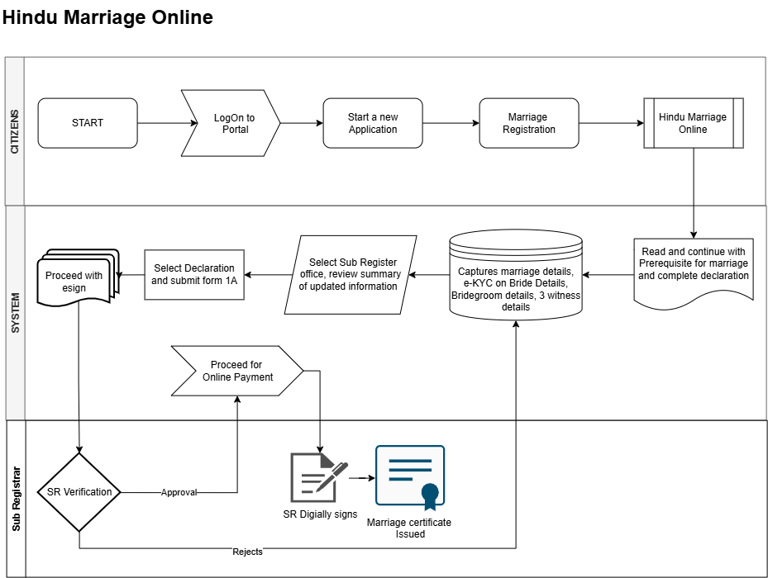
Figure: Hindu Marriage Online process
Flow (continuing from 7.2 step 7 — Online-specific steps):
# | Step | Lane | Notes
7 | Capture marriage / e-KYC/Face Authentication on Bride details / Bridegroom / 3 witness details | System / Citizen | Per Online diagram: e-KYC / Face Authentication applied on Bride details during capture (Bridegroom e-KYC / Face Authentication)
8 | Select Sub-Registrar office and review summary of updated information | System / Citizen | Jurisdiction routing
9 | Submit Form I (Memorandum) and Form IA (Application) | System / Citizen | Form I & Form IA generated for the selected office
10 | Proceed with eSign | System / Citizen | Citizen eSign on Form I and Form IA
11 | SR Verification (decision) | Sub Registrar | Approve or Reject
11a | Reject → return to Enter Marriage / Bride / Bridegroom / Witness details | Sub Registrar → System | Citizen corrects and resubmits; refusal reason recorded
12 | Proceed for Online Payment | System / Citizen | Payment occurs only after SR approval
13 | SR Digitally signs | Sub Registrar | DSC applied
14 | Marriage certificate Generated | Sub Registrar / System | Form II-A available for download

Key characteristics: channel before combined prerequisite+declaration; e-KYC / Face Authentication on Bride details during capture; office selection + summary; Form I & Form IA + eSign; no printout, no appointment, no DEO; single SR verification; payment only after SR approval; fully digital signature chain.

7.4 To-Be process — Hindu Marriage Offline
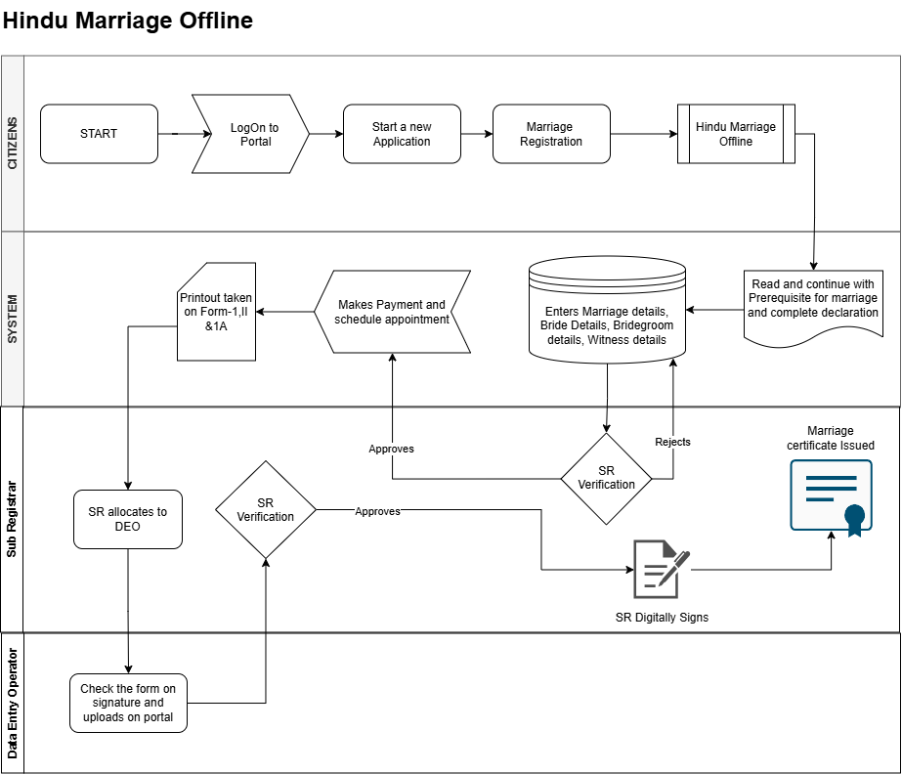
Figure: Hindu Marriage Offline process

Flow (continuing from 7.2 step 7 — Offline-specific steps):
# | Step | Lane | Notes
8 | SR Verification — Stage 1 (decision) on captured application data | Sub Registrar | Approve or Reject
8a | Reject → return to Enter Marriage / Bride / Bridegroom / Witness details | Sub Registrar → System | Citizen corrects and resubmits
9 | Makes Payment and schedule appointment | System / Citizen | Payment and slot booking in one step, after Stage 1 approval
10 | Printout taken on Form-1 | System / Citizen | Citizen prints the statutory forms
11 | SR allocates to DEO | Sub Registrar | Explicit allocation step per updated Offline diagram before DEO upload
12 | Parties and witnesses sign physically; citizen attends the SRO on the appointment date | Citizen (offline activity) | Not a system step; precondition for DEO upload
13 | Check the form on signature and uploads on portal | Data Entry Operator | DEO verifies signatures are present/complete, scans and uploads
14 | SR Verification — Stage 2 (decision) on the uploaded signed forms | Sub Registrar | Approve or Reject
14a | Reject → return to DEO check / upload step | Sub Registrar → DEO | Re-check or re-upload; does not go back to citizen data entry
15 | SR Digitally Signs | Sub Registrar | DSC applied
16 | Marriage certificate Issued | Sub Registrar / System | Form II-A issued

Key characteristics: channel before combined prerequisite+declaration; SR Verification Stage 1 on captured data before payment; payment + appointment bundled; printout of Form I, Form IA & II-A; SR allocates to DEO; DEO signature check and upload; SR Verification Stage 2 on uploaded signed forms (reject returns to DEO); SR DSC then certificate.

7.5 To-Be process — Special Marriage (Intended Marriage) Notice Generation Online
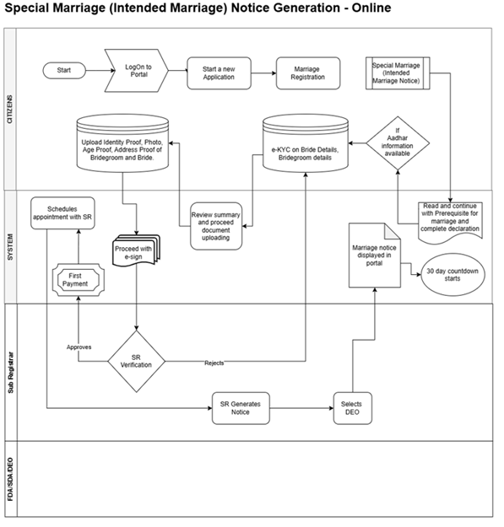
Figure: Special Marriage (Intended Marriage) Notice Generation — Online
Flow (continuing from 7.2 common intake — Online notice-specific steps):
# | Step | Lane | Notes
8 | If Aadhaar available → e-KYC on Bride & Bridegroom details | System / Citizen | Per Online notice diagram
9 | Review summary and proceed document uploading | System / Citizen | Summary of captured particulars
10 | Upload Identity Proof, Photo, Age Proof, Address Proof (Bridegroom & Bride) | Citizen | Mandatory supporting documents for notice
11 | Proceed with eSign | System / Citizen | Citizen eSign on notice application
12 | SR Verification (decision) | Sub Registrar | Approve or Reject
12a | Reject → return to e-KYC / review / upload | Sub Registrar → Citizen | Citizen corrects and resubmits
13 | First Payment | System / Citizen | Notice fee per Karnataka Special Marriage fee schedule
14 | Schedule appointment with SR | System / Citizen | After first payment
15 | SR Generates Notice | Sub Registrar | Statutory notice (Second Schedule / Sec. 5–6)
16 | Selects DEO | Sub Registrar | Assign publication / office follow-up
17 | Marriage notice displayed in portal | System | Sec. 6 publication (digital)
18 | 30-day countdown starts | System | Objection period per Sec. 7
Key characteristics: e-KYC on Bride & Bridegroom when Aadhaar available; document upload + eSign; SR verification before First Payment & appointment; SR generates notice and selects DEO; portal display of marriage notice; 30-day countdown (Sec. 7).

7.6 To-Be process — Special Marriage (Intended Marriage) Notice Generation Offline
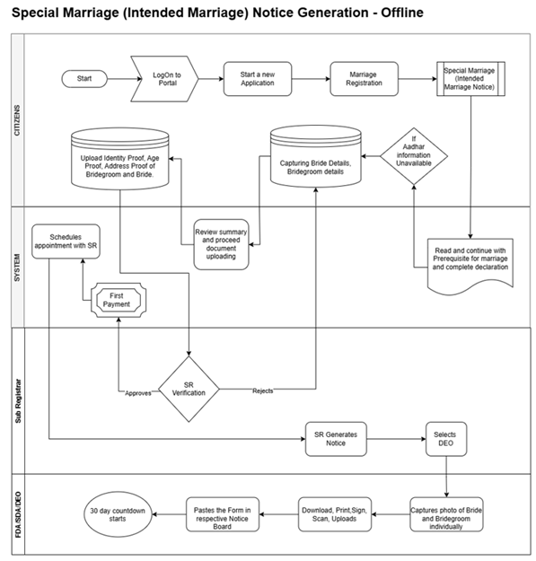
Figure: Special Marriage (Intended Marriage) Notice Generation — Offline
Flow (continuing from 7.2 common intake — Offline notice-specific steps):
# | Step | Lane | Notes
8 | If Aadhaar unavailable → capture Bride & Bridegroom details | System / Citizen | Manual capture path on Offline diagram
9 | Review summary and proceed document uploading | System / Citizen
10 | Upload Identity / Age / Address proofs (Bridegroom & Bride) | Citizen | Mandatory documents
11 | SR Verification (decision) | Sub Registrar | Approve or Reject
11a | Reject → return to capture Bride / Bridegroom details | Sub Registrar → Citizen | Resubmit
12 | First Payment | System / Citizen | Notice fee
13 | Schedule appointment with SR | System / Citizen
14 | SR Generates Notice | Sub Registrar | Statutory notice generation
15 | Selects DEO | Sub Registrar | Assign FDA/SDA/DEO
16 | Capture individual photos of Bride & Bridegroom | FDA / SDA / DEO | Office visit activity
17 | Download, Print, Sign, Scan and Upload notice | FDA / SDA / DEO | Physical notice processed into system
18 | Paste form on respective Notice Board | FDA / SDA / DEO | Sec. 6(2) conspicuous place publication
19 | 30-day countdown starts | System | Objection period per Sec. 7
Key characteristics: capture without mandatory e-KYC path when Aadhaar unavailable; SR verification → First Payment → appointment; SR generates notice & selects DEO; physical notice-board paste (Sec. 6(2)); 30-day countdown.

7.7 To-Be process — Special Marriage (Intended Marriage) Marriage Registration
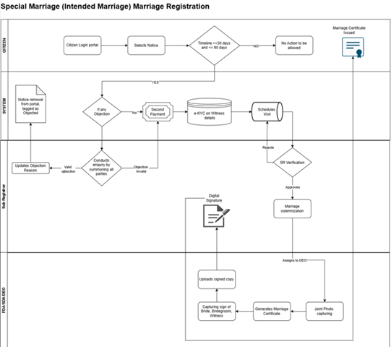
Figure: Special Marriage (Intended Marriage) Marriage Registration
Flow (after notice publication / 30-day period — registration steps):
# | Step | Lane | Notes
1 | Citizen Login portal | Citizen | Continue from published notice
2 | Select Notice | Citizen | Choose approved / published notice
3 | Validate timeline ≥ 30 days and ≤ 90 days | System | If NO → No Action allowed (Sec. 7 / Sec. 14)
4 | If any Objection? | System | Branch to SR enquiry when objection exists
4a | Conduct enquiry by summoning all parties | Sub Registrar | Sec. 8–9
4b | Valid objection → update reason; Notice removal from portal (Objected) | Sub Registrar / System | Process stops for solemnization
4c | Objection invalid → continue | Sub Registrar | Proceed to Second Payment
5 | Second Payment | System / Citizen | Registration / solemnization fee
6 | e-KYC on Witness details | System / Citizen | Three witnesses (Sec. 11)
7 | Schedule Visit | System / Citizen | Office visit for solemnization
8 | SR Verification (decision) | Sub Registrar | Approve or Reject
8a | Reject → return to Schedule Visit | Sub Registrar → System | Reschedule / correct
9 | Marriage solemnization | Sub Registrar | Sec. 12; declarations Sec. 11
10 | Assigns to DEO | Sub Registrar | Certificate production
11 | Joint Photo capturing | FDA / SDA / DEO
12 | Generate Marriage Certificate | FDA / SDA / DEO | Fourth Schedule
13 | Capture signs of Bride, Bridegroom, Witness | FDA / SDA / DEO
14 | Upload signed copy | FDA / SDA / DEO
15 | Digital Signature (DSC) | Sub Registrar
16 | Marriage Certificate Issued | Citizen / System | Download from portal
Key characteristics: notice selection with statutory timeline gate; objection enquiry branch (valid objection removes notice); Second Payment; witness e-KYC; schedule visit; SR solemnization; DEO joint photo, certificate, signatures; SR DSC; certificate issuance (Fourth Schedule).

7.8 To-Be process — Special Marriage Other Forms Notice Generation Online

Figure: Special Marriage Other Forms Notice Generation — Online
Flow (continuing from 7.2 common intake — Other Forms Online notice steps):
# | Step | Lane | Notes
8 | If Aadhaar available → e-KYC on Bride & Bridegroom details | System / Citizen | Per Other Forms Online notice diagram (mirrors Intended Marriage Online notice)
9 | Review summary and proceed document uploading | System / Citizen | Summary of captured particulars
10 | Upload Identity Proof, Photo, Age Proof, Address Proof (Bridegroom & Bride) | Citizen | Mandatory supporting documents for notice
11 | Proceed with eSign | System / Citizen | Citizen eSign on notice application
12 | SR Verification (decision) | Sub Registrar | Approve or Reject
12a | Reject → return to e-KYC / review / upload | Sub Registrar → Citizen | Citizen corrects and resubmits
13 | First Payment | System / Citizen | Notice fee per Karnataka Special Marriage fee schedule
14 | Schedule appointment with SR | System / Citizen | After first payment
15 | SR Generates Notice | Sub Registrar | Statutory notice (Second Schedule / Sec. 5–6)
16 | Selects DEO | Sub Registrar | Assign publication / office follow-up
17 | Marriage notice displayed in portal | System | Sec. 6 publication (digital)
18 | 30-day countdown starts | System | Objection period per Sec. 7
Key characteristics: Online e-KYC / upload / eSign → SR verification → First Payment & appointment → SR notice generation → portal publication → 30-day countdown (Sec. 16 public notice period).

7.9 To-Be process — Special Marriage Other Forms Notice Generation Offline

Figure: Special Marriage Other Forms Notice Generation — Offline
Flow (continuing from 7.2 common intake — Other Forms Offline notice steps):
# | Step | Lane | Notes
8 | If Aadhaar unavailable → capture Bride & Bridegroom details | System / Citizen | Per Other Forms Offline notice diagram (mirrors Intended Marriage Offline notice)
9 | Review summary and proceed document uploading | System / Citizen
10 | Upload Identity / Age / Address proofs (Bridegroom & Bride) | Citizen | Mandatory documents
11 | SR Verification (decision) | Sub Registrar | Approve or Reject
11a | Reject → return to capture Bride / Bridegroom details | Sub Registrar → Citizen | Resubmit
12 | First Payment | System / Citizen | Notice fee
13 | Schedule appointment with SR | System / Citizen
14 | SR Generates Notice | Sub Registrar | Statutory notice generation
15 | Selects DEO | Sub Registrar | Assign FDA/SDA/DEO
16 | Capture individual photos of Bride & Bridegroom | FDA / SDA / DEO | Office visit activity
17 | Download, Print, Sign, Scan and Upload notice | FDA / SDA / DEO | Physical notice processed into system
18 | Paste form on respective Notice Board | FDA / SDA / DEO | Sec. 6(2) conspicuous place publication
19 | 30-day countdown starts | System | Objection period per Sec. 7
Key characteristics: Offline capture/upload → SR verification → First Payment & appointment → SR notice → DEO print/sign/scan/upload and notice-board paste → 30-day countdown.

7.10 To-Be process — Special Marriage Other Forms Marriage Registration
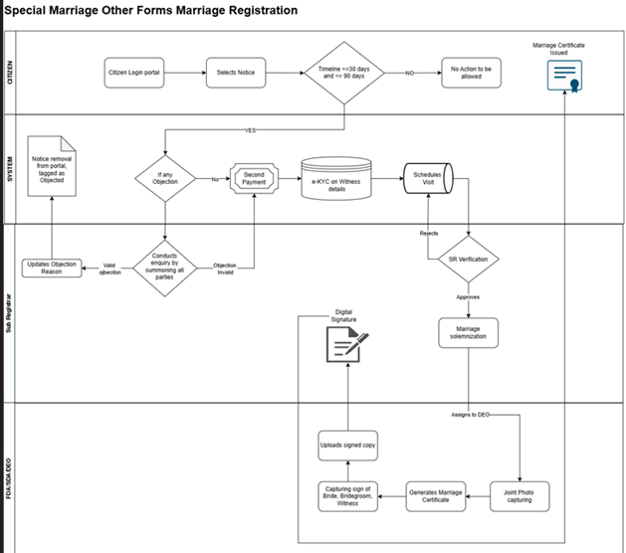
Figure: Special Marriage Other Forms Marriage Registration
Flow (after Other Forms notice publication — registration steps):
# | Step | Lane | Notes
1 | Citizen Login portal | Citizen | Continue from published notice
2 | Select Notice | Citizen | Choose approved / published notice
3 | Validate timeline ≥ 30 days and ≤ 90 days | System | If NO → No Action allowed (Sec. 7 / Sec. 14)
4 | If any Objection? | System | Branch to SR enquiry when objection exists
4a | Conduct enquiry by summoning all parties | Sub Registrar | Sec. 8–9
4b | Valid objection → update reason; Notice removal from portal (Objected) | Sub Registrar / System | Process stops for solemnization
4c | Objection invalid → continue | Sub Registrar | Proceed to Second Payment
5 | Second Payment | System / Citizen | Registration / solemnization fee
6 | e-KYC on Witness details | System / Citizen | Three witnesses (Sec. 11)
7 | Schedule Visit | System / Citizen | Office visit for solemnization
8 | SR Verification (decision) | Sub Registrar | Approve or Reject
8a | Reject → return to Schedule Visit | Sub Registrar → System | Reschedule / correct
9 | Marriage registration / solemnization (per Other Forms diagram) | Sub Registrar | Chapter III Sec. 15–16; diagram includes SR registration step
10 | Assigns to DEO | Sub Registrar | Certificate production
11 | Joint Photo capturing | FDA / SDA / DEO
12 | Generate Marriage Certificate | FDA / SDA / DEO | Fifth Schedule (Sec. 16)
13 | Capture signs of Bride, Bridegroom, Witness | FDA / SDA / DEO
14 | Upload signed copy | FDA / SDA / DEO
15 | Digital Signature (DSC) | Sub Registrar
16 | Marriage Certificate Issued | Citizen / System | Download from portal
Key characteristics: select notice with timeline gate; objection enquiry branch; Second Payment; witness e-KYC; schedule visit; SR verification and registration steps per diagram; DEO certificate production & signatures; SR DSC; certificate issuance (Fifth Schedule).

7.11 Application status model (channel-aware)
Status | Description | Channel | Actor | Next states
Draft | Saved not submitted | Both | Citizen | Channel selected
Channel selected | Online or Offline chosen (before prerequisites) | Both | Citizen | Prerequisite & declaration completed
Prerequisite & declaration completed | Combined prerequisite + declaration acknowledged | Both | Citizen | Details captured
Details captured | Marriage / bride (Online: e-KYC / Face Authentication) / bridegroom / witness details saved | Both | Citizen | Office selected (Online) / Pending SR verification Stage 1 (Offline)
Office selected & summary reviewed | SRO office chosen, summary confirmed | Online | Citizen | Form I & Form IA submitted
Form I & Form IA submitted | Form I (Memorandum) and Form IA submitted | Online | Citizen | eSign pending
eSign pending | Awaiting citizen eSign | Online | Citizen | Pending SR verification
Pending SR verification | Awaiting SR scrutiny | Online / Offline (Stage 1) | SR | Approved for payment / Rejected — data
Rejected — data correction | Sent back to citizen data entry | Both | SR | Details captured
Approved for payment | SR approved; fee payable | Both | SR | Payment completed
Payment completed | Fee paid, receipt issued | Both | System | Pending SR digital signature (Online) / Appointment scheduled (Offline)
Appointment scheduled | SRO visit slot booked | Offline | Citizen | Forms printed
Forms printed | Form printout taken | Offline | Citizen | Allocated to DEO
Allocated to DEO | SR has allocated the application to a DEO | Offline | SR | Awaiting signed-form upload
Awaiting signed-form upload | Physically signed forms pending at SRO | Offline | Citizen / DEO | Signed forms uploaded
Signed forms uploaded | DEO checked signatures and uploaded | Offline | DEO | Pending SR verification — Stage 2
Pending SR verification — Stage 2 | Awaiting SR scrutiny of signed forms | Offline | SR | Pending SR digital signature / Rejected — upload
Rejected — upload | Sent back to DEO for re-check / re-upload | Offline | SR | Signed forms uploaded
Pending SR digital signature | Awaiting DSC | Both | SR | Registered
Registered | Serial / page / volume assigned, Form II endorsed | Both | SR | Certificate issued
Certificate issued | Form II-A Generated / downloadable | Both | System | Closed
Closed | No further action | Both | System | —

8. Functional requirements

8.1 Eligibility and module entry
Req ID | Requirement | Priority
FR-HMA-001 | System shall allow registration only for marriages claimed to be solemnized under HMA 1955 (Section 2 applicability) | Must
FR-HMA-002 | System shall block or warn if marriage date is in future | Must
FR-HMA-003 | System shall enforce minimum age at date of marriage: bridegroom 21, bride 18 (Section 5(iii)) | Must
FR-HMA-004 | System shall capture marital status at time of marriage (unmarried / widower / widow / divorced) per Form I | Must

8.2 Jurisdiction and office routing
Req ID | Requirement | Priority
FR-HMA-005 | Applicant shall select basis for jurisdiction: place of marriage | Must
FR-HMA-006 | System shall route application to Sub-Registrar office matching selected jurisdiction (anywhere in district) | Must

8.3 Data capture — marriage details (Form I items 1–2)
Req ID | Requirement | Priority
FR-HMA-007 | Capture date of marriage | Must
FR-HMA-008 | Capture place of marriage with sufficient particulars to locate (address, district, state) | Must
FR-HMA-009 | Capture description of ceremony / rites (Section 7) | Should

8.4 Data capture — bridegroom (Form I)
Req ID | Requirement | Priority
FR-HMA-010 | System shall capture bridegroom particulars as per Form I (name, parentage, age/DOB, addresses, marital status, signature/eSign, email optional, mobile) | Must
Field (statutory) | Mandatory | Validation / notes | Kaveri 3.0 field name
Full name | Y | Shall be imported through e-KYC | [TBD]
Father's name | Y
Mother's name | Y
Age at marriage | Y | Cross-check DOB, Shall be imported through e-KYC (if available)
Current address of residence | Y | Shall be imported through e-KYC
Permanent address of residence | Y
Status (unmarried/widower/divorced) | Y
Signature + date | Y | e-sign
Email | O
Mobile | Y

8.5 Data capture — bride (Form I)
Req ID | Requirement | Priority
FR-HMA-011 | System shall capture bride particulars as per Form I (name, parentage, age/DOB, addresses, marital status, signature/eSign, email optional, mobile); Online channel applies e-KYC / Face Authentication per FR-HMA-058 | Must
Field (statutory) | Mandatory | Validation / notes | Kaveri 3.0 field name
Full name | Y | Shall be imported through e-KYC | [TBD]
Father’s name | Y
Mother’s name | Y
Age at marriage | Y | Cross-check DOB, Shall be imported through e-KYC (if available)
Current address of residence | Y | Shall be imported through e-KYC
Permanent address of residence | Y
Status (unmarried/widower/divorced) | Y
Signature + date | Y | e-sign
Email | O
Mobile | Y

8.6 Data capture — witnesses (Form I)

Req ID | Requirement | Priority | Acceptance criteria
FR-HMA-012 | System shall capture exactly three witnesses | Must
FR-HMA-013 | Each witness: full name, blood relation if any, age, current and residence, address, signature + date | Must
FR-HMA-014 | Witness identity verification via [Aadhaar e-KYC / Face Authentication / manual] | Must

Field (statutory) | Mandatory | Validation / notes | Kaveri 3.0 field name
Full name | Y | Shall be imported through e-KYC | [TBD]
Age | Y | Cross-check DOB, Shall be imported through e-KYC (if available)
Current address of residence | Y | Shall be imported through e-KYC
Permanent address of residence | Y
Signature + date | Y | e-sign
Mobile | Y

8.7 Form I — memorandum generation and completeness
Req ID | Requirement | Priority
FR-HMA-015 | Generate Form I (Memorandum of Marriage) in duplicate per Rule 4(1) for the selected office | Must
FR-HMA-016 | Ensure Form I includes all statutory particulars (items 1–7) and is e-signed (signed) by the bride, bridegroom and three witnesses | Must
FR-HMA-017 | Populate Form I date and place of marriage from captured marriage details (Form I items 1–2) | Must

8.7A Form IA — application and declarations
Req ID | Requirement | Priority
FR-HMA-083 | Generate Form IA addressed to Registrar of Marriage for selected office | Must
FR-HMA-084 | Capture statutory declarations on Form IA: (I) valid marriage registrable under Section 8; (II) Section 5 conditions satisfied; (III) particulars true to best knowledge | Must
FR-HMA-085 | Capture solemnization date in Form IA narrative (align with Form I date of marriage) | Must

8.8 Supporting documents and memorandum
Req ID | Requirement | Priority
FR-HMA-018 | Upload joint photo of bride and bridegroom (Form I header) | Must
FR-HMA-019 | Document checklist: [age proof, address proof, divorce decree if applicable — DE to confirm] | Must

8.9 Fees and payments
Req ID | Requirement | Priority
FR-HMA-020 | Applicable fee as per the Karnataka fees of schedule | Must
FR-HMA-021 | Issue payment receipt equivalent | Must
FR-HMA-022 | System shall enable the payment step only after SR approval (Online: SR Verification; Offline: SR Verification Stage 1) | Must
FR-HMA-023 | Offline channel: payment and appointment scheduling shall be completed as a single guided step | Must
FR-HMA-024 | System shall not permit certificate generation unless payment is successfully reconciled | Must
FR-HMA-025 | Handle payment failure / timeout with retry without re-triggering SR verification | Must

8.10 SRO scrutiny and registration
Req ID | Requirement | Priority | Acceptance criteria
FR-HMA-026 | SRO shall view complete application, documents, payment status | Must
FR-HMA-027 | SRO may require parties to remedy defects | Must | Audit trail
FR-HMA-028 | SRO shall refuse incomplete Form I (memorandum) or Form IA with brief written order communicated to parties | Must
FR-HMA-030 | On completion: issue Form II-A certificate immediately | Must | download

8.11 Post-registration services
Req ID | Requirement | Priority | Acceptance criteria
FR-HMA-031 | Bride and Bride Groom Registers | Should
FR-HMA-032 | Receipt Prints | Should
FR-HMA-033 | Certificate print / reprint with audit controls | Should
FR-HMA-034 | Marriage search / certified extract retrieval | Should
FR-HMA-035 | Export registered marriage data to Kutumba portal, Civil Registration System and Labour Department | Should

8.12 Notifications
Req ID | Requirement | Priority | Acceptance criteria
FR-HMA-036 | SMS/email on submission, query, rejection, registration, certificate | Should
FR-HMA-037 | Kannada + English certificates | Should
FR-HMA-038 | Citizen shall see a channel-specific application progress tracker mirroring the published Online/Offline process steps | Should | Current step highlighted; status from 7.5 model

8.13 Reports and MIS
Req ID | Requirement | Priority | Acceptance criteria
FR-HMA-039 | Register-wise marriage count by period | Must
FR-HMA-040 | Pending scrutiny | Should
FR-HMA-041 | Fee collection reconciliation report | Must
FR-HMA-042 | Channel-wise MIS: volumes, approval / rejection rates and cycle time split by Online vs Offline | Should
FR-HMA-043 | Offline appointment MIS: booked, honoured, no-show, reschedule counts per office | Should
FR-HMA-044 | Rejection analysis by stage (SR Stage 1 vs Stage 2) and reason code | Should
FR-HMA-045 | Daily register update report per SRO office | Should

8.14 Channel selection and prerequisite acknowledgement
(Ref: 7.2 steps 5–6 — both diagrams; channel then combined prerequisite+declaration)
Req ID | Requirement | Priority | Acceptance criteria
FR-HMA-046 | After channel selection, system shall display a combined Prerequisite for marriage and complete declaration screen that the citizen must read and explicitly continue from | Must | Acknowledgement timestamped and audited
FR-HMA-047 | System shall present a channel choice (Hindu Marriage Online or Hindu Marriage Offline) immediately after Marriage Registration service selection and before the prerequisite+declaration screen | Must | Selection stored on the application
FR-HMA-048 | System shall explain the practical difference at the point of choice (eSign vs printout + physical signature + SRO appointment) | Must | Bilingual EN/KN
FR-HMA-049 | Selected channel shall drive all subsequent screens | Must
FR-HMA-050 | Both channels shall reuse the same combined prerequisite+declaration and core data-capture screens (7.2 steps 6–7), with Online applying e-KYC / Face Authentication on Bride/groom details | Must | Single source of validation logic

8.15 Online channel — office selection, Form I & Form IA submission and eSign
(Ref: 7.3 steps 7 nuance + 8–10)
Req ID | Requirement | Priority | Acceptance criteria
FR-HMA-051 | Citizen shall select the Sub-Registrar office and view a summary of all updated information before submission | Must | Summary shows marriage, bride, bridegroom, witness data
FR-HMA-052 | Citizen shall be able to return and edit any required sections | Must | No data loss
FR-HMA-053 | System shall generate and allow submission of Form I (Memorandum) from captured data | Must | Form I generated for the selected office; filed with Form IA (FR-HMA-086)
FR-HMA-054 | System shall support eSign on Form I by the required signatories (parties and three witnesses) | Must | (parties, witnesses)
FR-HMA-055 | eSign artefacts (signed PDF, signature metadata, timestamp) shall be stored and rendered immutable | Must | Retrievable for audit and SR review
FR-HMA-056 | System shall handle eSign failure / abandonment with resumable retry | Must | Status remains eSign pending
FR-HMA-057 | Application shall move to SR verification only after eSign is complete | Must | Mandatory
FR-HMA-058 | Online channel: system shall perform e-KYC / Face Authentication on Bride details during application capture (per Online process diagram) | Must | e-KYC / Face Authentication success recorded before summary/office selection; failure blocks progress with clear message
FR-HMA-086 | System shall generate and allow submission of Form IA with the selected declaration (accompanies Form I per Rule 4(2)) | Must | Form IA addressed to the selected office
FR-HMA-087 | System shall support eSign on Form IA / declarations by the required party signatories | Must | Signed Form IA stored with Form I eSign artefacts

8.16 Offline channel — printout, physical signature and DEO upload
(Ref: 7.4 steps 9–13 including SR allocates to DEO)
Req ID | Requirement | Priority | Acceptance criteria
FR-HMA-059 | On Stage 1 approval, citizen shall pay the fee and schedule an appointment at the selected SRO (before printout and SR→DEO allocation) | Must | Slot, date, time, office recorded
FR-HMA-060 | System shall provide appointment slot availability, confirmation, and reschedule / cancel rules | Should | Rules
FR-HMA-061 | System shall generate a printout of Form I with exact wordings | Must | Legal sign-off on templates; Kannada rendering correct
FR-HMA-062 | Printout shall carry application reference, appointment details and a machine-readable identifier ( QR) for retrieval at the counter | Should | Enables DEO lookup
FR-HMA-063 | DEO shall retrieve the application, check that the printed forms are signed (parties and three witnesses) and upload the scanned forms to the portal | Must | Checklist-driven; per-form confirmation
FR-HMA-064 | DEO shall record a signature-completeness checklist outcome, not merely attach a file | Must | Each required signature ticked
FR-HMA-065 | System shall validate uploads (file type, size, page count) | Must | Reject malformed uploads
FR-HMA-066 | DEO shall be able to replace / re-upload documents when SR rejects at Stage 2 | Must | Version history retained
FR-HMA-067 | All DEO actions shall be attributed to the individual operator and audited | Must
FR-HMA-068 | DEO access shall be restricted to applications of their own SRO office | Must | Jurisdiction-scoped RBAC
FR-HMA-069 | After printout, SR shall explicitly allocate the application to a DEO before the DEO can check signatures and upload (per Offline diagram) | Must | Unallocated applications do not appear in DEO upload queue; allocation audited

8.17 SR verification (channel-aware)
(Ref: 7.3 step 11; 7.4 steps 8 and 14)
Req ID | Requirement | Priority | Acceptance criteria
FR-HMA-070 | Online: SR shall verify the eSigned application in a single verification stage | Must | Approve / Reject with reason
FR-HMA-071 | Offline Stage 1: SR shall verify captured application data before payment and appointment | Must | Approve / Reject with reason
FR-HMA-072 | Offline Stage 2: SR shall verify the uploaded physically signed Form I | Must | Approve / Reject with reason
FR-HMA-073 | Rejection at Online SR verification and at Offline Stage 1 shall return the application to the citizen data-entry step | Must | Editable sections, reason visible to citizen
FR-HMA-074 | Rejection at Offline Stage 2 shall return the application to the DEO upload step, not to citizen data entry | Must | Citizen data remains locked
FR-HMA-075 | Every verification decision shall record actor, timestamp, stage, decision and reason code + reason text | Must | Immutable audit
FR-HMA-076 | Rejection shall be issued as a brief written/typed order (DSC signed) communicated to the parties | Must | PDF + notification
FR-HMA-077 | SR queue shall clearly distinguish Online, Offline Stage 1 and Offline Stage 2 work items | Must | Filter + count by stage

8.18 Digital signature and certificate issuance
(Ref: 7.3 steps 13–14; 7.4 steps 15–16)
Req ID | Requirement | Priority | Acceptance criteria
FR-HMA-078 | SR shall digitally sign using a valid DSC before the certificate is issued, in both channels | Must | Signature verifiable on the PDF
FR-HMA-079 | System shall block certificate generation if DSC is unavailable / expired, with a clear message | Must | No unsigned certificate leaves the system
FR-HMA-080 | On SR digital signature: assign serial no., page, volume, update register, then issue Form II-A (certificate) | Must | Ref FR-HMA-029 / FR-HMA-030
FR-HMA-081 | Certificate shall be issued and made available per channel: Online — portal download; Offline — counter hand-over and download | Must | Delivery mode recorded
FR-HMA-082 | Certificate shall carry integrity features (QR) | Must | Verifiable

9. Business rules
Rule ID | Description | Statutory ref | System enforcement
BR-HMA-001 | No registration without three witness signatures on memorandum | Rule 4(3) | Hard stop; FR-HMA-012/013
BR-HMA-002 | Form I (Memorandum) must be accompanied by Form IA (Application) and both must be complete before filing | Rule 4(2) | Hard stop; FR-HMA-015 / FR-HMA-083
BR-HMA-003 | Age at marriage ≥ statutory minimum | Sec. 5(iii) | Validation; FR-HMA-003
BR-HMA-004 | Neither party married at time of marriage | Sec. 5(i) | Declaration; FR-HMA-004 / FR-HMA-046 / FR-HMA-084
BR-HMA-005 | Marriage must be solemnized (past date) | Sec. 7, 8 | Date ≤ today; FR-HMA-002 / 007
BR-HMA-006 | Jurisdiction routing as per Rule | Rules 1966 | Office master; FR-HMA-005/006
BR-HMA-007 | Rejection must be in writing | Rule 4(3) scrutiny clause | Rejection PDF; FR-HMA-028 / 076
BR-HMA-008 | Combined prerequisite + declaration screen must be acknowledged after channel selection and before data entry begins | Process diagram (both) | Hard gate 7.2 step 6; FR-HMA-046
BR-HMA-009 | Exactly one channel (Online / Offline) applies to an application at a time; channel is selected before prerequisites | Process diagram (both) | Channel attribute; FR-HMA-047/049
BR-HMA-010 | Fee is payable only after SR approval — no payment before the first SR verification | Process diagram (both) | Payment gate; FR-HMA-022
BR-HMA-011 | Online: application cannot reach SR verification without completed eSign | Online diagram | Hard stop; FR-HMA-057
BR-HMA-012 | Offline: printout of Form I is available only after payment and appointment booking | Offline diagram | Print gated; FR-HMA-061
BR-HMA-013 | Offline: forms may be uploaded only by a DEO of the same SRO office, after signature check | Offline diagram | RBAC + checklist; FR-HMA-063/068
BR-HMA-014 | Offline Stage 2 rejection returns work to the DEO, never directly to the citizen | Offline diagram | Workflow; FR-HMA-074
BR-HMA-015 | Certificate is issued only after the SR digital signature in both channels | Both diagrams | DSC pre-condition; FR-HMA-078
BR-HMA-016 | Offline: an appointment is mandatory before signed forms can be uploaded | Offline diagram | Upload gated; FR-HMA-059/063
BR-HMA-017 | Rejected applications retain full history of prior submissions and decisions | Audit / Rule 4 | Versioned records; FR-HMA-075
BR-HMA-018 | Online: Bride/Groom details capture requires successful e-KYC / Face Authentication before proceeding to office selection / summary | Online diagram | Hard stop; FR-HMA-058
BR-HMA-019 | Offline: DEO upload is permitted only after SR has allocated the application to that DEO | Offline diagram | Queue gated; FR-HMA-069
BR-HMA-020 | Form IA statutory declarations (I)–(III) must be captured and acknowledged before Online submission / eSign | Form IA / Rule 4(2) | Hard stop; FR-HMA-084 / FR-HMA-086

10. User interface (high-level)
Screen / step | Purpose | Channel | Statutory alignment | Notes
Login / start application | Authenticated entry, new application | Both |  | 7.2 steps 2–3
Service selection | Choose Marriage Registration | Both |  | 7.2 step 4
Prerequisite + declaration | Combined read-and-continue eligibility, documents and statutory declarations | Both | Sec. 5, 7, 8 | 7.2 step 6; FR-HMA-046
Channel selection | Hindu Marriage Online vs Offline (before prerequisites) | Both |  | 7.2 step 5; FR-HMA-047
(merged) Declarations | Merged into Prerequisite + declaration screen per updated diagrams — do not implement as a separate step | Both | Sec. 5, 7, 8 | Superseded — covered by FR-HMA-046
Marriage details | Date, place, jurisdiction | Both | Form I &1–2 | FR-HMA-007 / 008 / 009
Bride / Bridegroom | Party particulars; Online Bride via e-KYC / Face Authentication | Both | Form I 3–4 | FR-HMA-010 / FR-HMA-011 / FR-HMA-058
Witnesses (×3) | Witness particulars | Both | Form I &5–7 | FR-HMA-012 / 013 / 014
Document upload | Joint photo, proofs | Both | Form I | FR-HMA-018 / FR-HMA-019
Office selection + review summary | Choose SRO, review all captured data | Online | Rule 4 | FR-HMA-051 / FR-HMA-052
Form I submission | Generate and submit memorandum | Online | Form I / Rule 4(1) | FR-HMA-053
Form IA submission | Select declaration and submit application | Online | Form IA / Rule 4(2) | FR-HMA-083 / FR-HMA-086
eSign | Citizen electronic signature | Online | Form I & Form IA signatures | FR-HMA-054 / 055 / 056 / 057 / 087
Payment | Fee, after SR approval | Both | Form VI | FR-HMA-020–025; FR-HMA-022 gate
Appointment scheduling | Book SRO visit slot with payment | Offline |  | FR-HMA-059 / FR-HMA-060
Printout — Form I, IA, II-A | Generate printable statutory forms | Offline | Form I, IA, II-A | FR-HMA-061 / FR-HMA-062
DEO upload console | Signature checklist + upload of signed forms | Offline | Rule 4(3) | FR-HMA-063–068
SRO workbench | Verification queue (Online / Offline Stage 1 / Stage 2), allocation, register, refuse | Both | Form II, register | FR-HMA-026–030; FR-HMA-070–077
SR digital signature | Apply DSC before issuance | Both | Rule 4(5) | FR-HMA-078–082
Certificate view | Form II-A | Both | Rule 4(5) | FR-HMA-030 / FR-HMA-033 / FR-HMA-081
Application tracker | Channel-specific progress against diagram steps | Both |  | FR-HMA-038
SR allocates to DEO | Assign Offline application to DEO after printout | Offline |  | FR-HMA-069

Wireframe links: [Figma / prototype URLs]
Bilingual: All labels [EN / KN] — content manager sign-off.

11. Integrations
Integration | Direction | Purpose | Channel | Owner | Status
Payment gateway / Treasury | Outbound | Registration fee (post-approval) | Both |  | TBD
eSign service provider | Outbound | Citizen eSign on Form I and Form IA | Online |  | TBD
DSC / signing service | Outbound | SR digital signature before certificate issuance | Both |  | TBD
Aadhaar / e-KYC / Face Authentication | Outbound | Online Bride e-KYC / Face Authentication (mandatory per diagram); other party/witness identity as approved | Online (Bride); Both (other as approved) |  | TBD
DigiLocker | Outbound/Inbound | Document fetch; certificate push [TBD] | Both |  | TBD
SMS / email gateway | Outbound | Alerts incl. appointment confirmation & reminder | Both |  | TBD
Appointment / slot service | Internal | SRO visit slot availability and booking | Offline |  | TBD
Document / scan store | Inbound | DEO-uploaded signed Form I, Form IA & II-A | Offline |  | TBD
Existing Kaveri master data | Inbound | Districts, SRO offices, holiday calendar (for slots) | Both |  | TBD

Interface requirements: [API list TBD by Architect — must now include eSign, DSC signing, appointment slots and scan upload]

12. Data requirements

12.1 Core entities (logical)
- Application/Memorandum, Party (Bride/Bridegroom), Witness, MarriageEvent, Document, Payment, ScrutinyDecision, RegisterEntry (serial/page/volume), Certificate (Form II-A), Endorsement (Form II).

12.2 Retention
Permanent preservation of certificates and registers

12.3 Migration (high level)
Topic
Legacy Kaveri 1.0/2.0 marriage records and certified copies
Physical register back-scan

13. Requirements traceability matrix (RTM) - template
Req ID | Act/Rule/Form | Requirement summary | BRD section | UI screen | Test case ID | Status
FR-HMA-001 | Sec. 2 / HMA | System shall allow registration only for marriages claimed to be solemnized under HMA 1... | 8.1 | Service selection | TC-HMA-___ | Draft

14. Acceptance and sign-off
Role | Name | Signature / Date | Comments
Product Owner
Domain Expert
IGR nominee
Business Analyst

UAT scope: Test scenarios derived from FR-HMA-* (see 13 RTM), BR-HMA-* and statutory forms Form I / IA / II / II-A.

Appendix A — References
- The Hindu Marriage Act, 1955 — Acts_Rules/Marriage/Hindu Marriage Act, 1955.pdf
- Registration of Hindu Marriage (Karnataka) Rules, 1966 — Acts_Rules/Marriage/REGISTRATIONOFHINDUMARRIAGE_KARNATAKARULES_1966.docx
- Statutory forms — Acts_Rules/Marriage/hindu marriage forms.pdf, Acts_Rules/Marriage/Form1.pdf
- Marriage fee / process notification — Acts_Rules/Marriage/RD48MNMU2023-Notification-marriage.pdf (validate)
- Approved process diagram — Hindu Marriage Online — Process Diagrams/hindu marriage Online.png
- Approved process diagram — Hindu Marriage Offline — Process Diagrams/hindu marriage Offline.png
- Kaveri 3.0 Marriage prototype (UI reference only, not legal source) — MarriageRegistrationProtoTypeDesign/templates/hindu-marriage-*.html
- The Special Marriage Act, 1954 — Acts_Rules/Marriage/The Special Marriage Act, 1954.pdf
- Special Marriage (Karnataka) Rules, 1961 — Acts_Rules/Marriage/SpecialMarriage(Karnataka)Rules1961.pdf
- Special Marriage fees — Acts_Rules/Marriage/SpecialMarriageFees.docx
- Approved process diagram — Special Marriage (Intended Marriage) Notice Online — Process Diagrams/Special Marriage (Intended Marriage) Notice generation-Online.png
- Approved process diagram — Special Marriage (Intended Marriage) Notice Offline — Process Diagrams/Special Marriage (Intended Marriage) Notice generation- offline.png
- Approved process diagram — Special Marriage (Intended Marriage) Marriage Registration — Process Diagrams/Special Marriage (Intended Marriage) Marriage Registration.png
- Approved process diagram — Special Marriage Other Forms Notice Online — Process Diagrams/Special Marriage Other Forms Notice generation-Online.png
- Approved process diagram — Special Marriage Other Forms Notice Offline — Process Diagrams/Special Marriage Other Forms Notice generation- offline.png
- Approved process diagram — Special Marriage Other Forms Marriage Registration — Process Diagrams/Special Marriage Other Forms Marriage Registration.png

